|  |  |
| --- | --- |
|  | FPT ACADEMY INTERNATIONAL  FPT – APTECH COMPUTER EDUCATION |

Centre Name: ACE-HCMC-2-FPT.

Address: 590 Cach Mang Thang 8, District 3, Ho Chi Minh City, Viet Nam.

**[Kid-Zone]**

|  |  |  |
| --- | --- | --- |
| Supervisor: | Phạm Thị Lánh | |
| Term: | T1.2206.M1 | |
| Batch No: | 6 | |
| Group No: | 6 | |
| Order: | Full name | Roll No. |
| 1. | Lê Huỳnh An Khánh | Student1387814 |
| 2. | Nguyễn Thanh Liêm | Student1379709 |
| 3. | Lê Quang Đức | Student1387839 |
| 4. | Nguyễn Ngọc Hải Đăng | Student1394615 |
| 5. | Hoàng Quốc Hưng | Student1394602 |

Month 09 Year 2022

This is to certify that

**Mr. LÊ HUỲNH AN KHÁNH**

**Mr. NGUYỄN THANH LIÊM**

**Mr. LÊ QUANG ĐỨC**

**Mr. NGUYỄN NGỌC HẢI ĐĂNG**

**Mr. HOÀNG QUỐC HƯNG**

Have successfully Designed & Developed

**KID-ZONE**

Submitted by: **Ms. PHAM THI LANH**

Date Of Issue: September, 2022

Authorized Signature:

# Content

Content 3

Acknowledge 4

Synopsis 5

REVIEW 1 6

Problem Definition 7

Customer Requirements Specifications 9

Architecture and Design of the project 10

Site map 11

Screen shots 12

I. Homepage 12

II. Abc and Number 14

III. Animals 16

IV. Vegetable 18

V. About Us 20

VI. Contact 22

Task Sheet 23

REVIEW 2 24

WEBSITE USER INTERFACE 25

I. Homepage 25

# Acknowledge

As we understand that the eProject is a step-by-step learning environment that closely simulates the classroom and Lab based learning environment into actual implementation. It is a project implementation at your fingertips!! An electronic, live juncture on the machine that allows you to.

✓ Practice step by step i.e., laddered approach.

✓ Build a larger, more robust application.

✓ Usage of certain utilities in applications designed by the user.

✓ Single program to unified code leading to a complete application.

✓ Learn implementation of concepts in a phased manner.

✓ Enhance skills and add value.

✓ Work on real life projects.

✓ Give a real-life scenario and help to create applications more complicated and useful.

✓ Mentoring through email support.

We would like to send a great thank to our professor and others student for the adorable support during the time in the project.

Beside several mistakes we had made in the project, we hope to have more opportunities to widen our knowledge in the web developing world.

We also thank you so much for your information and the “demo” project from India APTECH to help us get more reality experience in this project. Since we have gained more experience from this project, we will not stop learning anything as much as we can to be more successful in the future.

Your Sincerely,

Team Group 06.

# Synopsis

- The Objective of this program we aim is to give a sample project to work on real life projects. These applications help us build a larger, more robust application.

- The objective is not to teach you JavaScript/Dreamweaver but to provide you with a real life scenario and help you create basic applications using the tools.

- Hence, we can revise the chapters before we start with the project.

- This project is meant for students who have completed the module of HTML5. These programs should be done in the Lab sessions with assistance of the faculty if required.

- It is very essential that a student has a clear understanding of the subject. Students should go through the project and solve the assignments as per requirements given.

# REVIEW 1

## Problem Definition

Website is designed for the Kids (Toddlers) for Learning ABC’s in more creative way. The website includes the ABC with A for …., B for….

Also it includes some nursery rhymes with images so that child can grasp more easily. One two three till 100 with and without spellings, some basic calculation of addition and subtraction. Prayers, Galleries of basic animals, plants, fruits, games colors, Sunday-Mondays and so on.

The website is to be developed for the Windows Platform using HTML5, JavaScript and Geolocation. The site should work well in all leading browsers including Chrome, IE, Firefox etc.

Here are some problems need to be resolved:

1. Home page must be designed by including various interactive images like of a child say prayer, brushing teeth, drinking milk and so on.

2. Navigation links must be included and must be designed in an interactive way so as to become more user friendly for the kids.

3. Font sizes must be selected appropriately thinking about the end users.

4. Navigation must be made user friendly.

5. Menus can be included such as :

- ABC.s

- abc.s

- 123….

- Table of 2, 3,4, 5

- Some nursery rhymes with relevant images.

- Basic colors

- Some animals

- Some Vegetables

- Sunday, Monday…

- January, February

- Addition (here allow the end user to enter the value and message must be prompted whether correct ans or incorrect)

- Subtraction (here allow the end user to enter the value and message must be prompted whether correct ans or incorrect)

6. Look and feel must be made user friendly.

7. Uniformity and Navigation must be made smooth throughout the website.

8. The “Contact Us” page should have the Address of the Company and the mail address which when clicked will invoke the local mail client from where they can send an email. Address of the Company should be displayed using GeoLocation API (eg. GoogleMaps).

## Customer Requirements Specifications

|  |
| --- |
| WEBMASTER: |
| Output:  ● Website interface, images, forms, …  ● Giving interaction |

|  |
| --- |
| HARDWARE / SOFTWARE REQUIREMENT: |
| Software:  ● Notepad/HTML editor  ● Dreamweaver  ● IE 5.0/ Netscape 6.0 |
| Hardware:  ● A minimum computer system that will help you access all the tools in the courses is a Pentium 166 or better  ● 64 Megabytes of RAM or better |

## Architecture and Design of the project

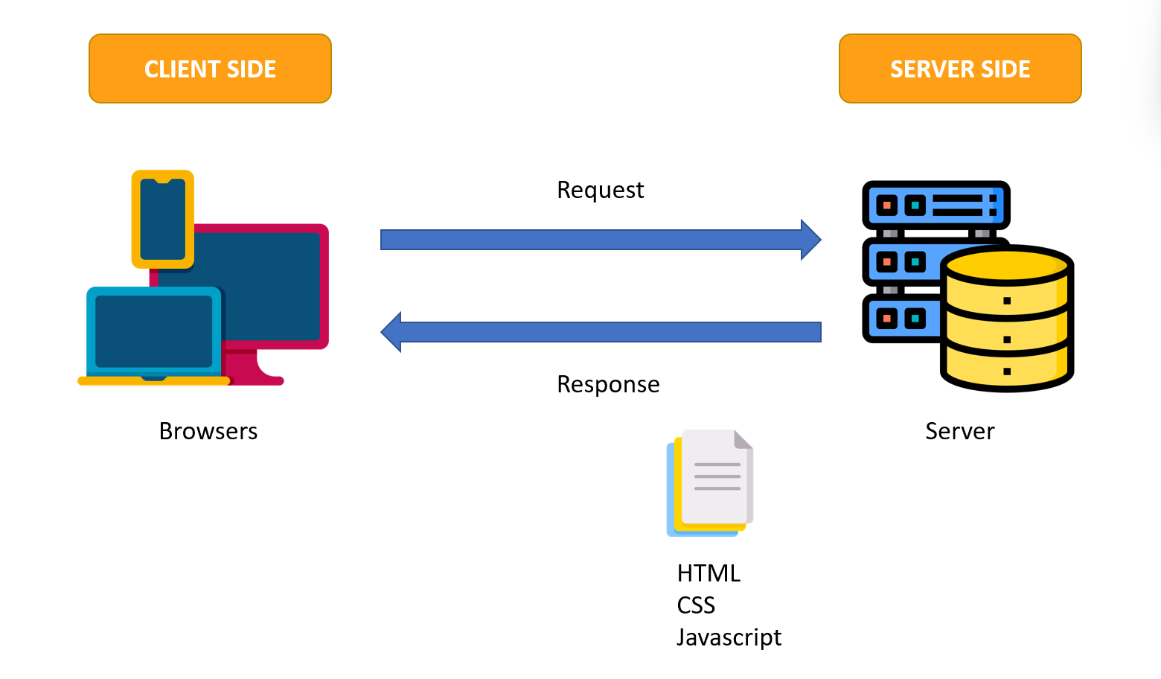

## Site map

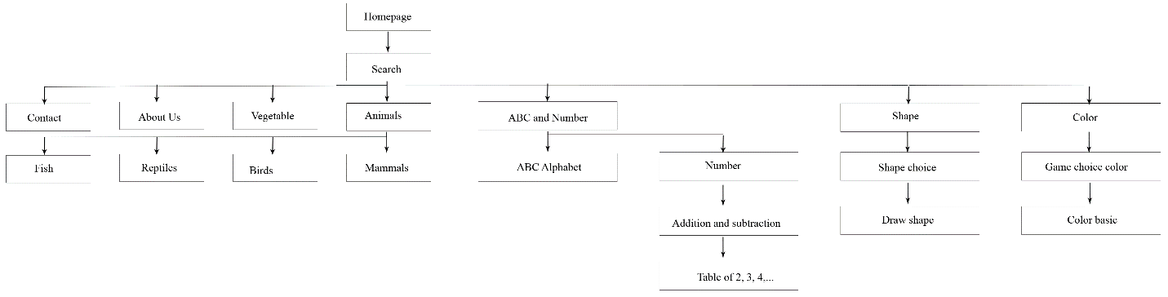

## Screen shots

### Homepage

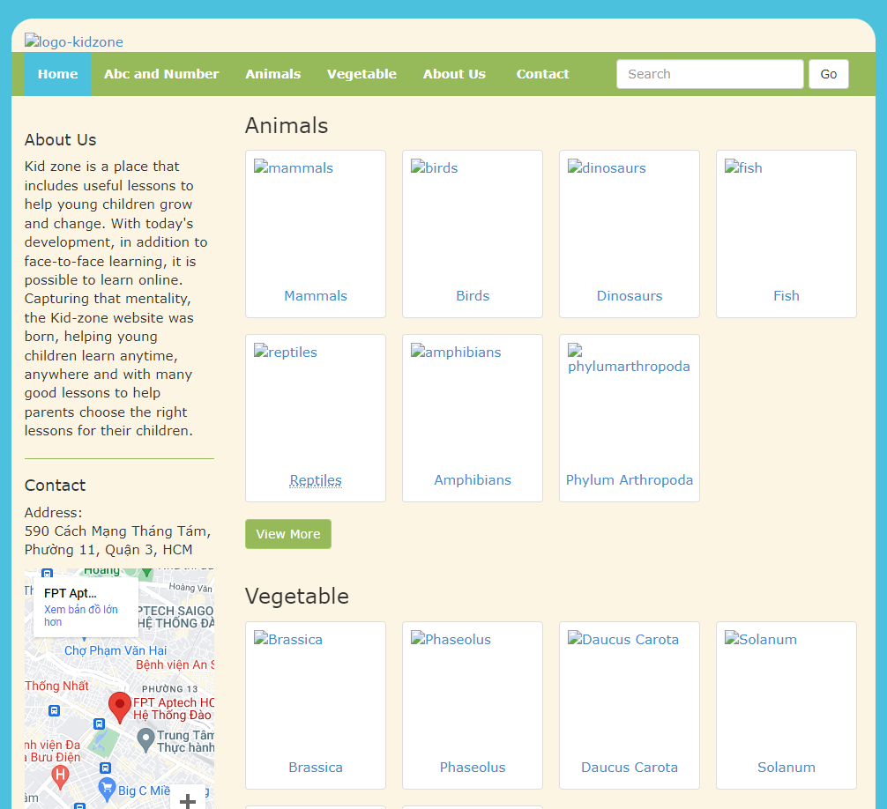

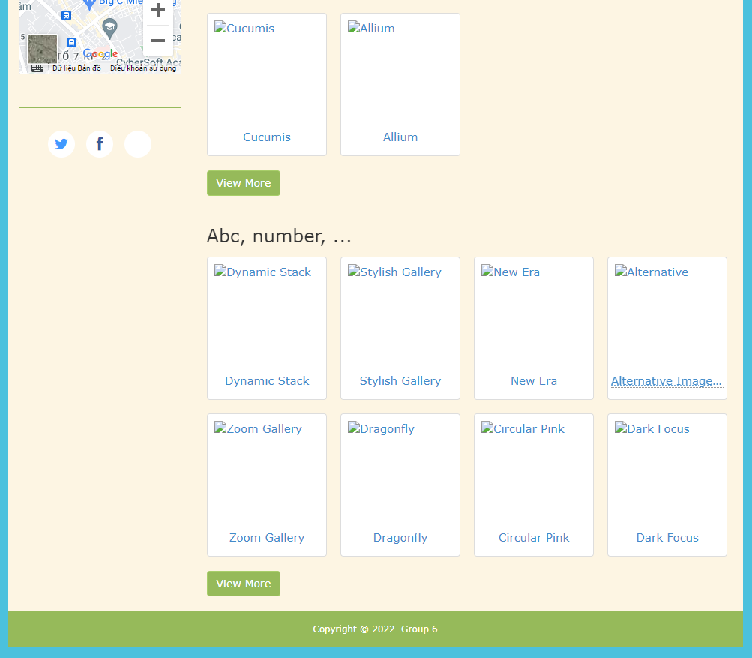

**Description**: This is homepage of Kid Zone, the top of this page is a header, after that is a navigation bar. The main part of a homepage beside the slider also includes 3 sections: animals, vegetable, abc and number,… . The footer of a homepage has 1 section: Copyright. The leftmost side has about us, contact and GeoLocation API

### Abc and Number

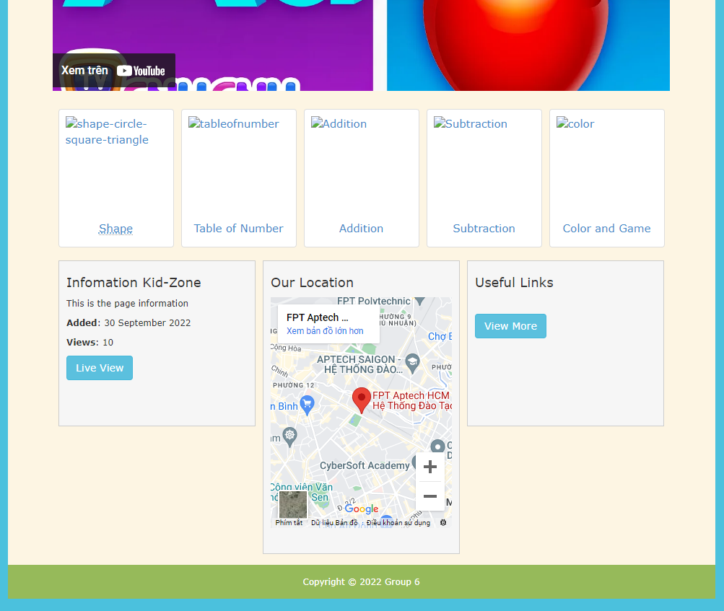

**Description**: When the user clicks on the Abc and Number tag in navigation, it will lead to this page. The main part of this page contains 4 sections: heading page, abc song, video song, suggestions links. The footer of page has 3 sections: Information Kid Zone, our location and useful links.

### Animals

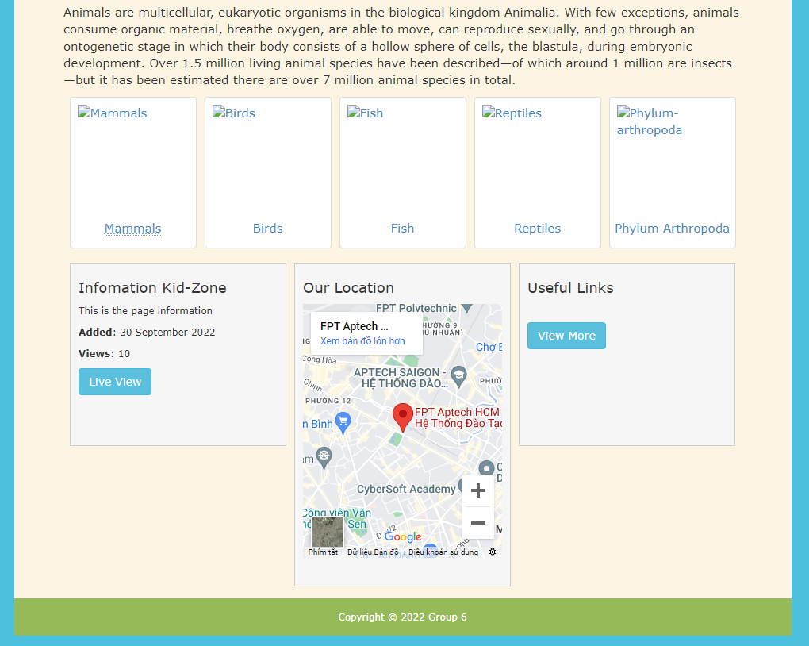

**Description**: When the user clicks on the Animals tag in navigation, it will lead to this page. The main part of this page contains 4 sections: heading page, picture animals, description animals, suggestions links. The footer of page has 3 sections: Information Kid Zone, our location and useful links.

### Vegetable

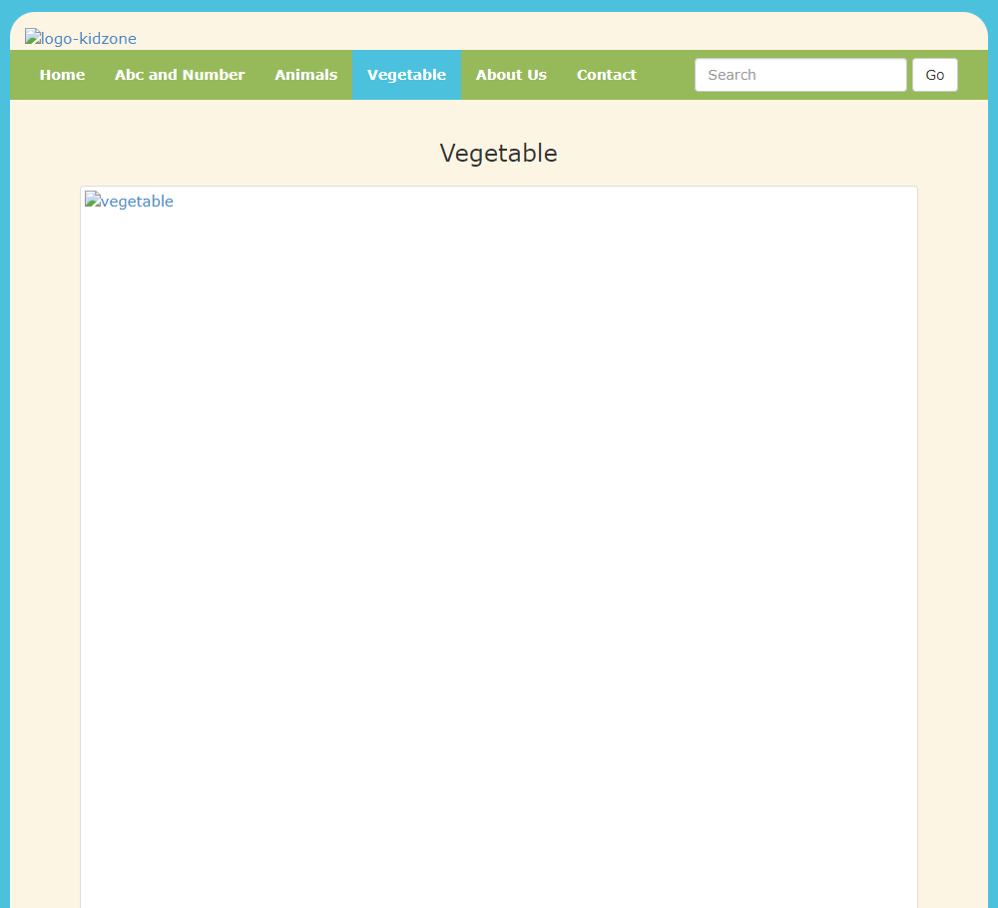

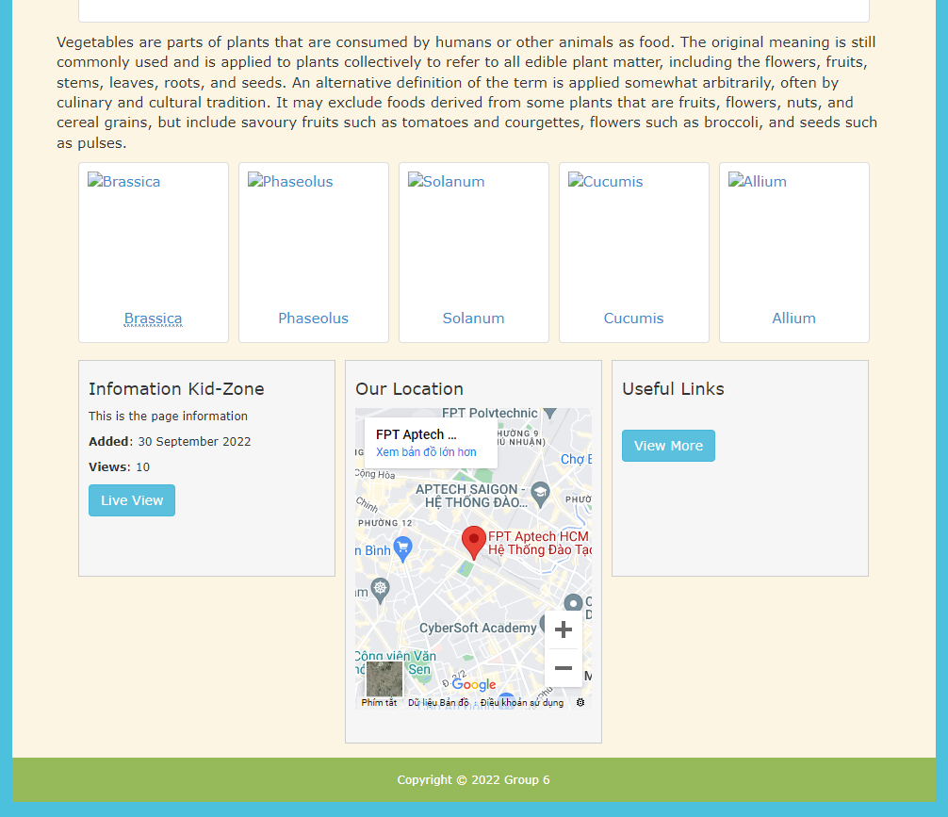

**Description**: When the user clicks on the Vegetable tag in navigation, it will lead to this page. The main part of this page contains 4 sections: heading page, picture animals, description animals, suggestions links. The footer of page has 3 sections: Information Kid Zone, our location and useful links.

### About Us

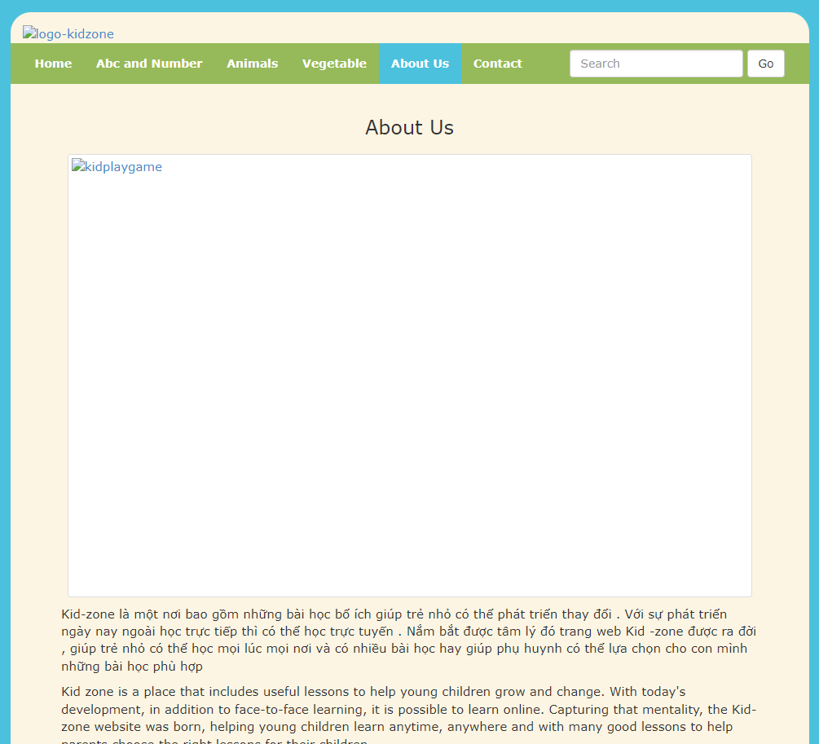

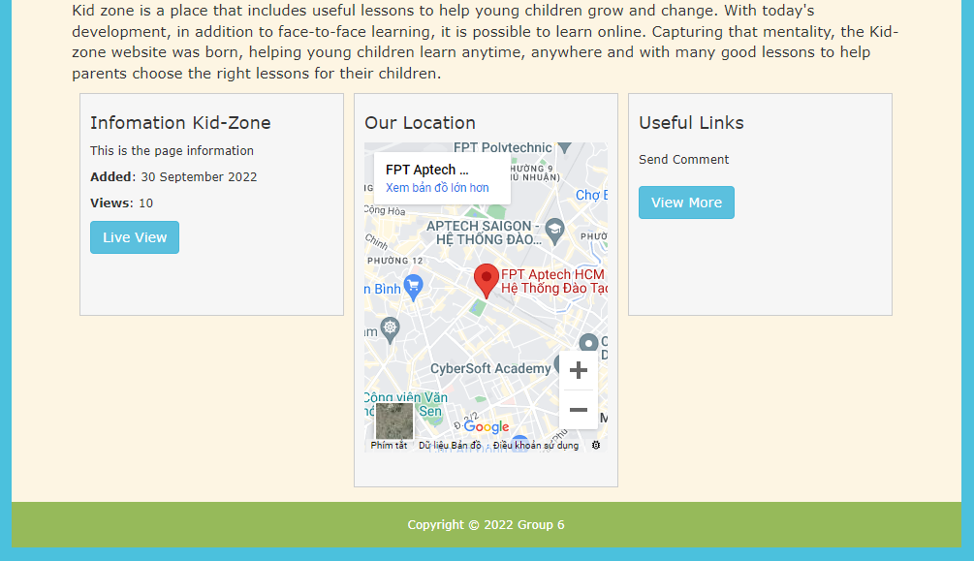

**Description**: When the user clicks on the About Us tag in navigation, it will lead to this page. The main part of this page contains 2 sections: picture kid, about the Kid Zone’s website. The footer of page has 3 sections: Information Kid Zone, our location and useful links.

### Contact

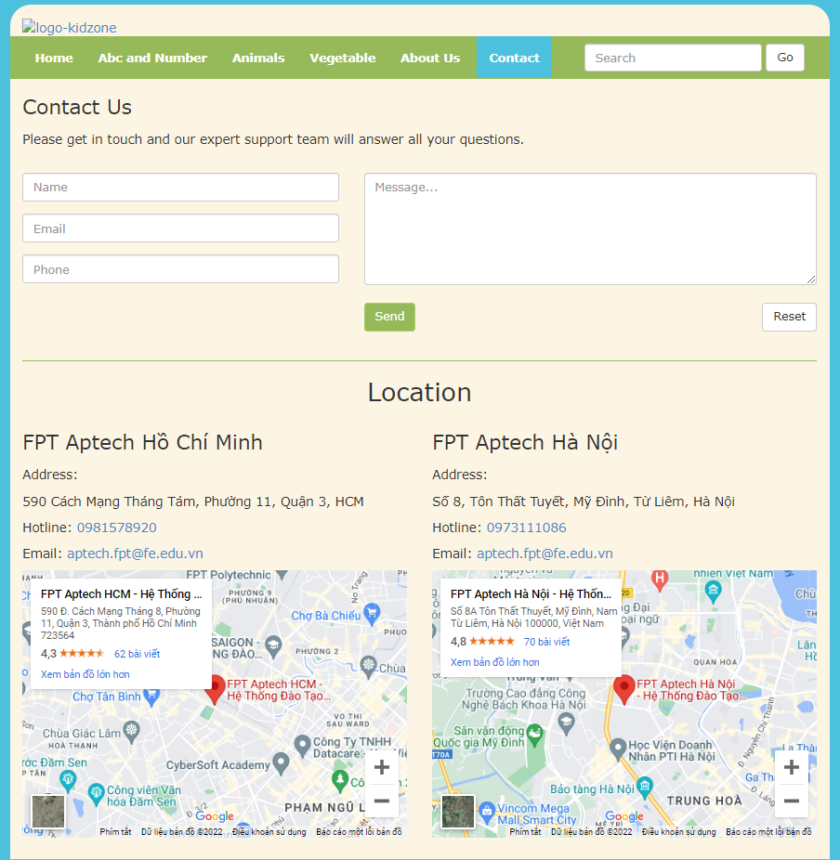

**Description**: After clicking the Contact tag on the navigation bar, the user will be redirected to this page. The first part of this page is a Send comments or questions to Kid Zone, beside it is a detailed location of Kid Zone’s Branches. The last part of this page is a map.

## Task Sheet

|  |  |  |  |  |  |  |
| --- | --- | --- | --- | --- | --- | --- |
| **Project Ref No.** | **Project Title – Ask Me Mobile** | **Activity Plan Prepared by** | **Date of preparation of Activity Plan** | | | |
| **Task** | **Actual Start Date** | **Actual Days** | **Teammate Names** | **Status** |
| Brainstorming ideas for layouts and Project Object | | Khánh, Đăng, Liêm, Đức | 05/10/2022 | 1 days | Khánh, Đăng, Liêm | Completed |
| Draw site maps and architecture design | | Khánh | 06/10/2022 | 1 days | Khánh | Completed |
| Wire framing general page layout | | Liêm | 06/10/2022 | 3 days | Liêm |  |
| Collect static assets (pictures, mp4, documentation,…) | | Khánh, Đăng, Liêm, Đức | 08/10/2022 | 3 days | Khánh, Đăng, Liêm, Đức |  |

# REVIEW 2

# WEBSITE USER INTERFACE

### Homepage

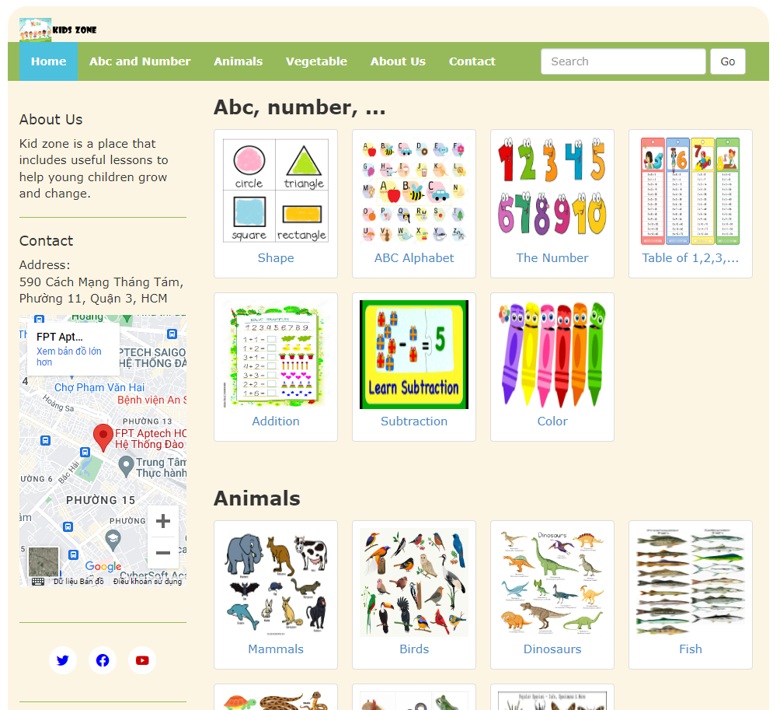

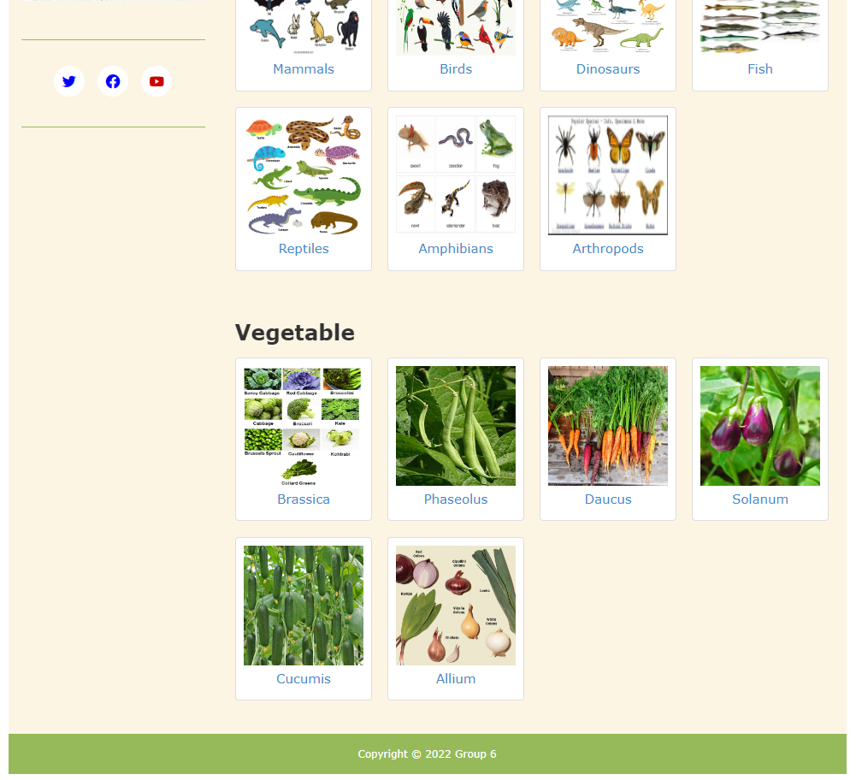

### ABC and Number, Animals, Vegetable

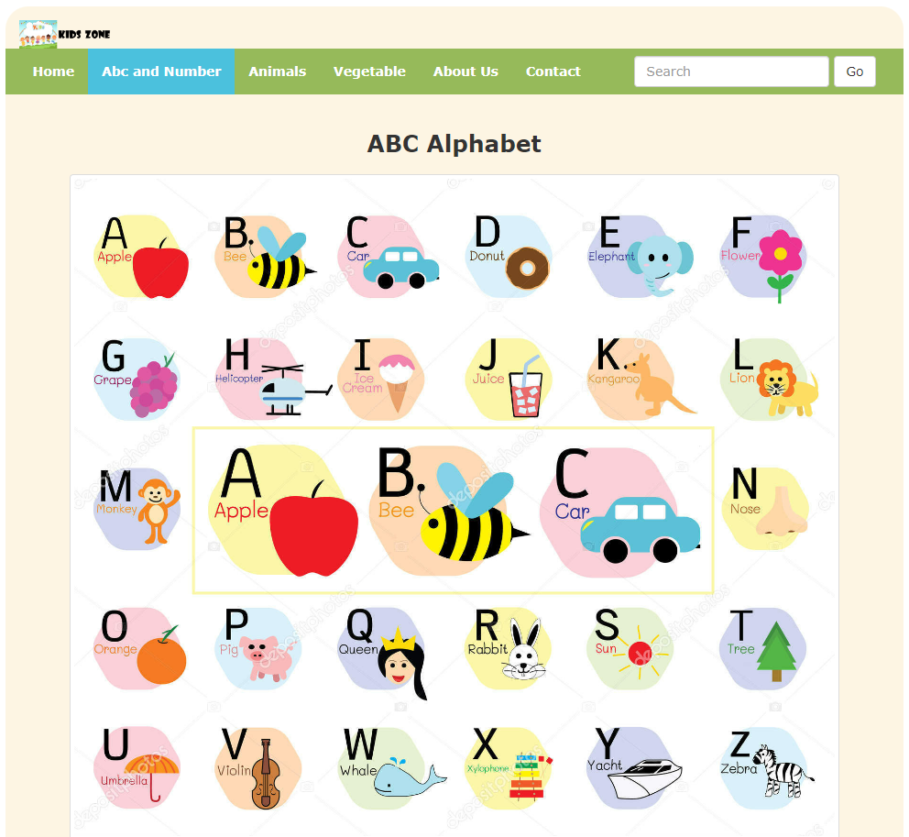

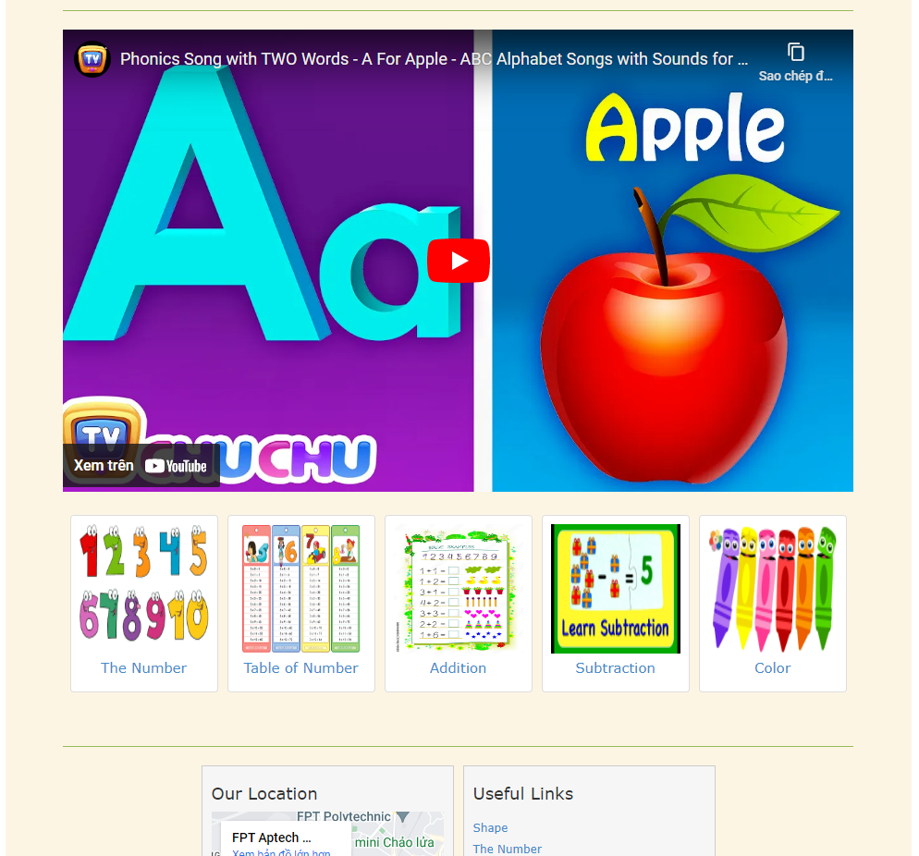



1. **About Us**

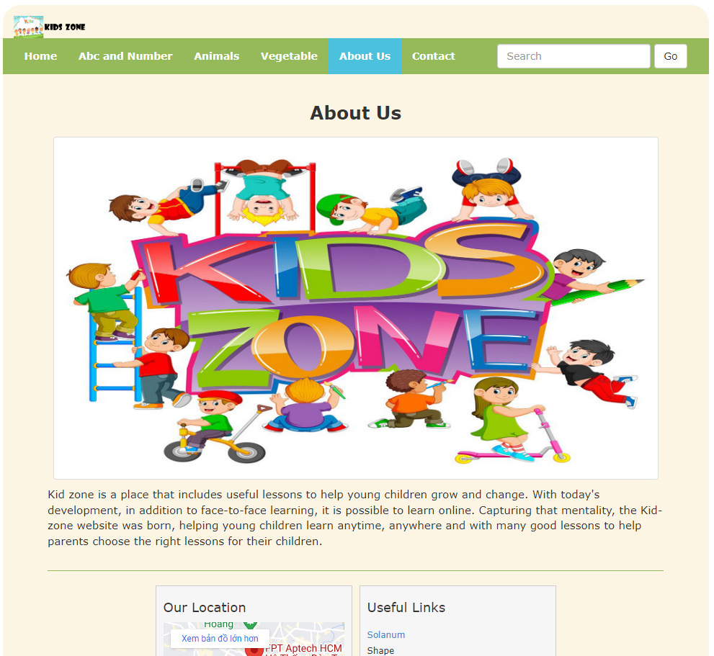



1. **Contact**

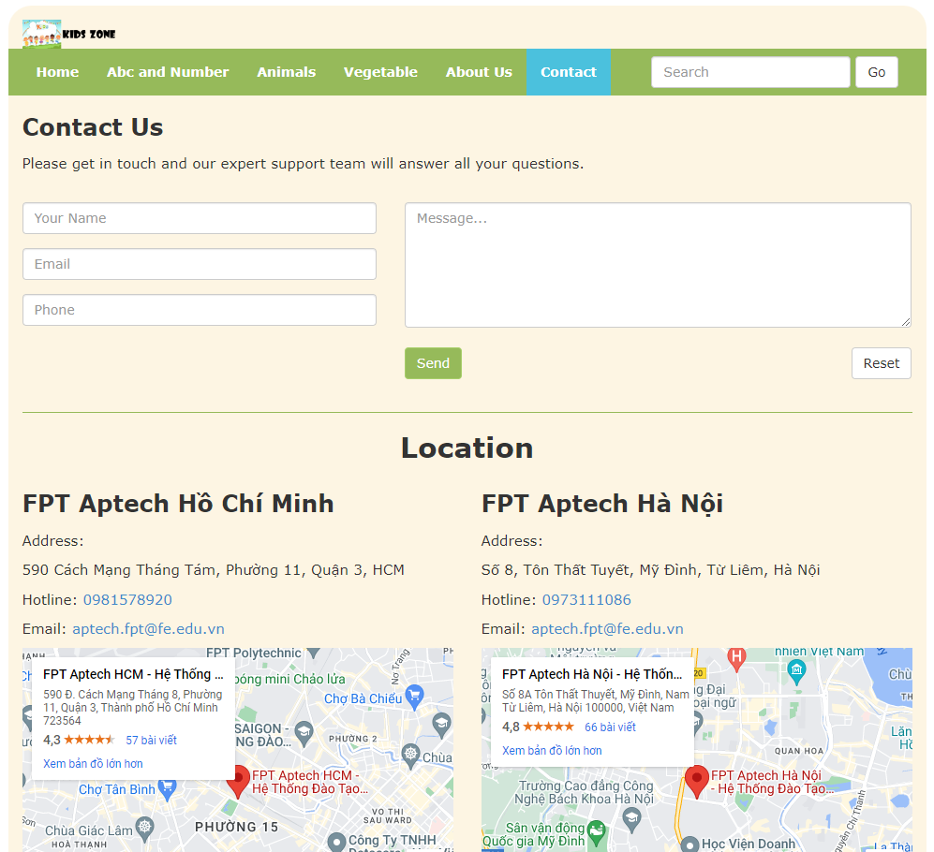

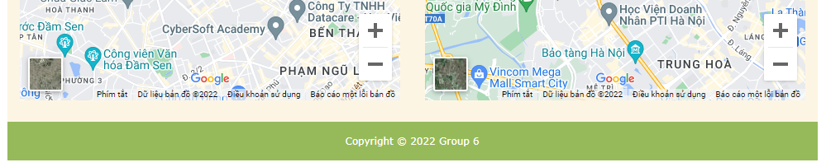

1. **Popup Content**

